

SYMBIOSIS LAW SCHOOL - PUNE
Care | Courage | Competence | Collaboration
Constituent of Symbiosis International (Deemed University), Lavale, Pune
Master of Laws (LL.M.)
Admission Prospectus for 2025
One Year Full-Time Post-Graduate Programme
(Cafeteria Approach with CGPA System)

Academic Year 2025-2026

- DIRECTOR’S PROFILE

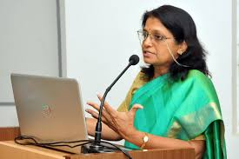
Prof. (Dr.) Shashikala Gurpur, Director, SLS, Pune, Dean, Faculty of Law, SIU, Jean Monnet Chair Professor (EUC- LAMP co-founded by EU) has an illustrious career over 32 years of experience in teaching, research and industry, is continuing with Symbiosis Law School since 2007. She is a distinguished academician and orator. She has received her formal schooling in Kannada medium in Gurpur, she holds degrees in science and law from Mangalore University. Dr. Gurpur received LLM as topper and gold medallist, and also her Ph.D. in International Law from Mysore University. She is featured amongst the illustrious 100 women personalities in the book namely ‘The Phenomenal She' launched by the Indian National Bar Association on 7th March 2022 and was listed among 100 legal luminaries of India in 2016 by Lexis Nexis. Dr. Shashikala Gurpur has been conferred the Annual Kittur Rani Chennamma Award, 2018-19 by the Government of Karnataka for her excellent achievement in the field of education and contribution to women empowerment. Dr Gurpur has more than 93 publications (26 Scopus/WoS), 16 Book Chapters and presented more than 330 invited lectures, workshops and seminars across India, Thailand, US, UK, Ireland, Germany, Australia, Canada and UAE. She is a pioneer of EU Legal Studies in India and was invited to serve on the selection committee of the 2022-23 Fulbright-Nehru Visiting Chair Program of Emory University by USIEF.
She is a Distinguished Visiting Professor at The West Bengal National University of Juridical Sciences, member of the Academic Council at Maharashtra National Law University, Aurangabad, resource person at NJA, Bhopal and PhD referee to many NLUs, JNU and many state universities. She is awarded with the most coveted professional achievement,' Jean Monnet Chair Professor for EU Climate Justice Law, Governance, Management and Policy (EUC-LAMP)' Co-funded by the Erasmus+ program of the European Union. She is team member of global evaluation and accreditation IALS, USA. She has guided 15 PhD, 100+ master’s thesis, and currently she is guiding eight students. She is a lead in the SPARC project, 4 EU Grants, NADFM training, MCCIA committee and the CII.
- ABOUT SYMBIOSIS LAW SCHOOL, PUNE

Symbiosis Law School, Pune (SLS, Pune) stands for excellence in legal education and is nestled in the city of Pune (popularly known as the Oxford of the East, with the glorious heritage of being the capital of the Peshwas). Symbiosis Law School, Pune piloted and enriched by the vision of Dr. S.B. Mujumdar, Chancellor, Symbiosis International (Deemed University) & Founder and President, Symbiosis, was established in 1977 under the illustrious banner of Symbiosis Society. SLS, Pune endeavors to secure all-round contributions for the betterment of the field of Law, to create world-class professionals, to produce committed academicians and law reformers, to train justice dispensers and invigorate community crusaders and, to create a strong watershed of new and upcoming expertise in law relating to business and corporate matters.
Symbiosis Law School, Pune has been ranked 5 in 2024 by National Institution Ranking Framework (NIRF) by the Ministry of Human Resource Development, Government of India. SLS Pune is at Rank 1 in CSR-GHRDC 2021 and Rank 1 in “Top law Schools in Maharashtra”, “Top Supreme Law Schools in India”, and “Top Law Schools in West Zone, India. In February 2021, the SLS Pune Team was applauded for their achievements in the areas of internationalization by being awarded ‘Excellence in Internationalization of Education’ by FICCI conferring the 7th FICCI Higher Education Excellence Awards-2021. SLS Pune also received the Best College Award amongst the top 3 in Virtual ‘IPTSE awards & IPTSE Conclave’ dated 28 April 2021 during the eve of World IP Day. SLS, Pune has been ranked top 10 amongst more than 1000 Law Schools in India by the India Today-Nielsen Survey, ranked 5th in the India Ranking 2024; 6th in India Ranking 2023: Law (NIRF 2023), Government of India. SLS Pune has been awarded All India Rank 1 and in the category of 'Top Supreme Law Schools' by the CSR-GHRDC Law Schools Survey 2022, 2023. SLS Pune has been awarded as the Best Law College by CSR in 2022, 2023, 2024 and ranked number 1 rank in Top 50 Private Law Colleges in India by IIRF 2022, 2023, 2024 Law category.

  - Significant Projects/ Courses
SLS, Pune has several impressive active international collaborations across prestigious international universities such as Berlin School of Economics and Law, Leibniz University, Hannover Brunswick European Law School, Ostfalia University of Applied Sciences, Germany, University College Cork, Ireland, NUI Galway, Ireland, University College Dublin, Ireland, Sofia University, Bulgaria, Jagiellonian University, Poland, Masaryk University, Czech Republic, Penn State University, USA, UNH School of Law, USA, Deakin University, Australia, University of Johannesburg, South Africa, National University of Singapore and many others. SLS Pune has proactively engaged with Arizona University, New Hampshire University, Washburn University, Seattle University, Pepperdine University, Waikato University, Bristol University, Vienna University of Economics and Business, and Shastri-Indo-Canadian Institute, etc. The collaboration has facilitated student-faculty mobility, participation in summer school, and organization of conferences, guest sessions, webinars, and research projects. SLS Pune has showcased a strong research culture along with an internationalization agenda that has resulted in successful project applications under the Erasmus + program of the EU. SLS, Pune had the unique distinction of being the only Indian partner with the Erasmus Mundus Global Consortium of Law Schools since 2008. SLS, Pune has been the recipient of four Erasmus+ CBHE KA2 under EU projects namely EURASIA, 21 Teach Skills Training, Climate Change Policy and Law, and International Law and Forced Migration Studies.
Under the EURASIA project, SLS Pune developed 28 courses related to EU studies which have been incorporated into program structures of BA /BBA LLB (Hons.), LLB as electives, and European Legal Studies (EU Law and International Law) has been incorporated in the LL.M. programme as a unique specialization.
SLS, Pune is a consortium partner of the ‘21st Century Teach Skills project’ which is related to the ‘Teacher’s Training with specialization on Life and IT skills’. As a part of this project, SLS Pune has developed 10 ECTS Courses on ‘Critical Thinking Skills’ and ‘Collaborative Problem-Solving Skills’. SLS, Pune under SIU is also a consortium partner of the project International Law and Forced Migration Studies. SLS Pune under the agies of SIU has been a part of DAAD -a New Passage to India with Berlin School of Economics and Law that facilitates faculty and student exchange. SLS Pune has also applied for a DAAD grant with Ostfalia University, Brunswick Germany. The institution is also a project partner in the ‘DET-Network.’ It has institutional memberships of some of the best international bodies recognized globally such as, the membership of IALS (International Association of Law Schools), ASLI (Asian Law Institute), IUCN and GAJE.
On the National front, SLS Pune has SPARC Project. SLS Pune has also undertaken the following projects under the Indian Council of Social Science Research related to ‘Law Trafficking and Disasters-tracing the interlinkages’; ‘Law Gender and Disasters-case study of Bundelkhand’. SLS Pune has been instrumental in influencing the new transformations in Criminal Justice Systems in India via submitting recommendations to the Ministry of Home Affairs under the Government of India. SLS Pune is also involved in research consultancy for Dr. Veerappa Moily, former Member of Parliament, India. SLS, Pune under the Nyaya Bandhu Scheme (PRO BONO CLUB) SLS Pune received a Grant of Rupees One Lakh (Rs. 1,00,000) from the Department of Justice, Government of India. Adding to its initiatives with the Government of India and the National Commission for Women, SLS Pune, organized the “Regional Consultation on Review of Criminal Law- Improvement in Status of Women” in February 2022 and submitted a detailed report to the National Commission for Women.
  - SCALSAR
SLSP has established the Symbiosis Centre for Advanced Legal Studies and Research (SCALSAR). It is the center stager research, quality publications, government interface, hosting scholars in residence, undertaking interdisciplinary legal studies and research projects, training teachers, and designing training modules.
SCALSAR was informally established in 2007 and was formalised and recognized as an excellence centre in the year 2013. SCALSAR envisions Ideas of architecture, infrastructure and resources for advanced legal studies and research. It promotes Research, training and consultancy in excellence centres aligned with SIU clusters having national and global importance in interdisciplinary and multidisciplinary areas.
It has 3 research clusters: Science Technology Innovation Law, Rule of Law in Context, and Comparative Law. Every year SCALSAR organizes an International Research Conference which has become popular as SYMROLIC representing the Rule of Law with Indian and Global perspectives, aligning it with the SIU’s vision of an interdisciplinary engagement by connecting to different fields such as that of Innovation, Science, Technology, Human Behaviour, Global Policy and Governance.
The purpose of SCALSAR under the Faculty of Law SIU, Symbiosis Law School Pune is to center-stage research, encourage quality publications, act as think-tank to the government, host scholars in residence, undertake interdisciplinary legal studies and research projects, train teachers and design training modules. SCALSAR contributes under three verticals viz. Science Technology and Innovation Law, Rule of Law in Context and International and Comparative Law and under 4 centres Symbiosis Center for Alternation Dispute Resolution (SCADR), Symbiosis Centre for International and Comparative Child Rights (SCICCR), Symbiosis Center for Climate Change Policy and Law (SCCCPL), Symbiosis Legal Skills Centre (SLSC) and 21st Teach Skills Lab and Symbiosis Culture, Language, Law and Justice Lab.
In the last year, the Centre has published more than 98 research papers in SCOPUS and WoS-indexed journals by the SLS Pune faculty members and some PG / Ph.D. students, now totalling up to 751 publications. Balancing the social agenda, the community legal care centre of SLS Pune is engaged in the Prison Advocacy Program of Mumbai High Court through Prison Clinic, collaborates with District Legal Aid Services Authority and has clinics in villages and inner city.

- THE CAREER & PROFESSIONAL DEVELOPMENT CELL
The Career & Professional Development Cell functions as the primary facilitatory body for the process of professional development and constructive employment for our students. The broad objectives of the cell are campus recruitment, training and development and internship opportunities. The Cell works throughout the year to implement and execute the processes of Campus Recruitments, Internships, Training and Development, Industry & Alumni Relations and Entrepreneurial development. With years of experience, the cell has developed a wide array of networks ranging from litigation firms, corporate firms, solicitors, private practitioners, to governmental commissions and agencies. The Career & Professional Development Cell has been tirelessly facilitating the professional development of our students and has been successful in attaining the aforementioned goals by providing our students with the best opportunities.
The LLM students are also provided with intensive training and guidance for JAG, NET, Civil Services, Judiciary Examination etc.
LLM students secured reputed placements with high CTC in firms / companies like Cummins India Limited, JM Financial Limited, Indusind Bank, Mercedes Benz, Bajaj Allianz, Indiabulls, Ernst & Young LLP, PwC, Phoenix Mills Limited, Mthree (A Wiley Company), Piaggio Vehicles Pvt Ltd., Integreon, I-PAC, Juris Arena, Legasis, DSK Legal, Tech Mahindra, Stakeholders Empowerment Services, AAN Legal, Magma HDI, Atkins Realis, DWF Legal and many more in others sectors.

- THE ALUMNI CELL
The Alumni Cell of Symbiosis Law School, Pune is a voluntary student body working under the guidance of Director, Symbiosis Law School Pune and Dean Faculty of Law Symbiosis International (Deemed University). The Cell continuously undertakes to strengthen the relations of the alumni of SLS Pune. It has been instrumental in organising the Annual Alumni Meet, regular guest lectures by distinguished alumni in the campus, publishing the annual yearbook- ‘Alumni Nexus’. SLSP is the proud alma mater to illustrious alumni who have completed their LLM from SLSP, such as Mr. Rahul Kothari, Co-Founder of Squarely Legal and Distinguished Visiting Professor of Practice; Honey Mukesh Patel, Judicial Magistrate First Class, Civil Judge Junior Division; Henaa Mall, Barrister and Solicitor, Ontario, Canada; Nistha Pandey, Additional Chief Judicial Magistrate, Rajasthan High Court; Madhvi Datta, Partner, Kochhar & Co.; Saurabh Sinha, Research Attorney at Thomson Reuters amongst other law firm and corporate firm leaders. SLS, Pune endeavours to secure all-round contribution to the betterment in the field of law, to create world-class professionals, to produce committed academicians and law reformers, to train justice dispensers and invigorate community crusaders and, to create a strong watershed of new and upcoming expertise in law relating to business and corporate matters.

- PROGRAMME PROFILE

SLS, Pune offered 2-year LL.M program from 2003-2013. It is one of the pioneer institutions in the country to initiate the One-Year LL.M Programme in 2013. The post-graduate programme is offered through the Center for Postgraduate Legal Studies (CPLS), with an objective to create research-centric intellectuals and academicians. There is an emphasis on an interdisciplinary approach in the study of law and research orientation underlining the relevance of research methodology with utmost technical precision and scientific sophistication. The students have an option of a cafeteria approach in terms of specialization, cross specialization courses combining innovation, cutting edge legal acumen and theoretical insights.

With emphasis on research and publication under the umbrella of SCALSAR (Symbiosis Center for Advanced Legal Studies and Research), faculty and students are engaged in publishing the results of their research. The success reflects in a large number of students entering corporate sector, Law firms, academics, higher research, army and judicial services.

Specializations offered:

- Business and Corporate Law
- Constitutional Law and Administrative Law
- Innovation, Technology and Intellectual Property Law
- Criminal Law and Security Law
- Human Rights Law

Law, Policy and Good Governance

Family Law

EU Law and International Law

Telecommunication, Media and Technology Law

Climate Change Law and Policy* (Approval in process)

Note: A specialization will be offered subject to minimum 5 admissions in the Specialization Group.

Unique Features of the One Year LL.M. Programme:

Specialized Centre for Postgraduate Legal Studies (CPGLS) works in a unique association with Symbiosis Centre for Advanced Legal Studies and Research (SCALSAR).

Experienced &internationally trained faculty-members, including experts from the Bar & Bench and industry.

Unique differentiator of legal writing by US faculty.

Top class and up-to date academic content and mentor-faculty (1:10).

Peer learning with international students from different countries.

Special emphasis on Research and Publication – in the year 2023 around 97 articles are published affiliated to SI(DU) Pune in international and national journals of repute including 67 in Scopus/WOS journals. In the year 2024 (till August 2024) around 93 articles are published affiliated to SI(DU) Pune in international and national journals of repute including 80 in Scopus/WOS journals.

Institutionalized skill development through specialized Symbiosis Skill Centre.

Mapping of courses with skill centric sessions with a unique blend of theory and skills through mock teaching, dissertation, viva-voce, research methods, etc.

Comprehensive internationalization and collaborations including faculty & students exchange.

Compulsory European Union Law and Human Rights Law courses as international attribute to the courses with elaborate career mentoring.

Unique competencies for career in judiciary, industry, academia and profession.

State of the Art infrastructure.

ICT-enabled learning resources.

Comparative curriculum, innovative pedagogy and eminent visitors.

Structured career and placement guidance.

- Duration of the Programme: One Year (Full Time)
- Is Programme residential: No
- Medium of Instruction: English
- Pattern of Programme: Semester Pattern: Total 2 Semesters
- Sanctioned Intake: 100* (Approval in process)

- ELIGIBILITY

Three- or Five-years LL.B. Degree from any recognised University/ Institution of National Importance with a minimum of 50% marks or equivalent grade (45% marks or equivalent grade for Scheduled Caste/ Scheduled Tribes). Candidates who have appeared for the final year LL.B. examination may also apply, Subject to submission of passing certificate with minimum of 50% marks or equivalent grade (45% marks or equivalent grade for Scheduled Caste/ Scheduled Tribes). by the announced date.

Important: It is the responsibility of the candidate to ascertain whether he / she possesses the requisite qualification(s)/ eligibility for admission. Having been admitted provisionally does not mean acceptance of eligibility. Final eligibility of admission will be decided by Symbiosis International (Deemed University), subject to successful fulfilment of specified admission norms.

- RESERVATION OF SEATS: AS PER UNIVERSITY NORMS

- Within the sanctioned intake:
Scheduled Castes | 15%
Scheduled Tribes | 7.5%
Differently abled | 3%
- Over and above the sanctioned intake:
Kashmiri Migrants | 2 Seats
International Students | 20%

- ADMISSION PROCESS & IMPORTANT DATES- BATCH 2025-2026

  - Admission to LL.M. (One Year) programme is conducted through the following procedure:
Step 1: Apply online at symlaw.ac.in
Step 2: a. Appear for the All India Admission Test (AIAT) CBT (Centre Based Test)
b. Appear for Personal Interaction (Online PI)
- Symbiosis All India Admission Test (AIAT): -
All Admission to LL.M (One Year) is offered through Symbiosis All India Admission Test (AIAT), which will take place in a Centre Based Test (CBT) mode at select test centres across India. (The list of test centres may be found in the AIAT Registration Portal) The AIAT consists of:
- Written Test (CBT Mode) (comprising of objective and subjective written test to assess the aptitude for teaching, research, legal aptitude and basic legal knowledge)- Weightage 70 %
Test Duration: 105 minutes
- Personal Interview (PI) (Online) - (Personal Interview is intended to test the Personal Attributes, Fitment, Work Experience, Publications and Statement of Purpose)- Weightage 30%.
PI Duration: 10 minutes (approx.).

- Verification of Educational Qualification Documents and Eligibility
Candidates need to furnish their documents of educational qualification as per the directions of SLS Pune/SIU for verification at the time of appearing for the AIAT. If any candidate fails to furnish the documents at the time of appearing for the AIAT for verification the candidate will not be permitted to appear for the AIAT. Further, the candidates, who are shortlisted in the merit list after the AIAT, need to submit a list of documents to acquire eligibility to be admitted to the LL.M. Programme at Symbiosis Law School, Pune. If the candidate does not submit the document for eligibility purposes, admission of the same candidate stands cancelled.
Note: Candidates are requested to bring a Statement of Purpose (SOP) not more than (250 words) and one reference (one page each) from the Head or Supervisor of your Institute at the time of appearing for the PI. It will be verified as a part of the document verification process.
- Refund Policy
In case of cancellation of admission or non-fulfilment of eligibility criterion, the candidate may apply online for a refund of tuition fees and deposit. The refund will be made as per the refund policy of SIU.
- PREPARATION OF MERIT LIST & ALLOTMENT OF SPECIALISATION FOR LLM AT SLS PUNE:
  - Steps for preparation of merit list/s:
Step 1: Generic Merit List:
Process of preparation of first merit list:
Preparation of consolidated/generic merit list: A consolidated/generic merit list will be prepared as per the AIAT score and total intake for open and other reserved categories.
Hypothetical Example: If there are a total 50 seats for the open category, the institute will add around 20% to 30% extra i.e. 50+13=63 and prepare the consolidated/generic merit list of 63 candidates from the open category. These 63 candidates will be selected based upon their AIAT score irrespective of their preferred specialization.
Step 2: Allocation of specialisation: -
Allotment of the specialization to the candidates selected in consolidated/generic merit list: The candidate, who is selected in the consolidated/generic merit list, will be allotted a particular specialisation depending on:
(a) The marks scored in AIAT;
(b) The preferences of specialisations provided by the candidate while filling out the registration form for AIAT.
Allocation of the specialisation will be based upon the cut-off marks of the concerned specialisation as determined from the merit list and the number of seats in each specialization. The total number of seats shall be equally divided among all the offered specialisations in a particular academic year.
*Note: The offering of a specialisation in a particular academic year will be subject to minimum 5 admissions in the concerned specialisation group.
- Process of allotment of specialization to the candidates selected in consolidated/generic merit list:
After the preparation of consolidated/generic merit list, the institute will start allotting the specialisation for each candidate from consolidated/generic merit list based upon their marks in AIAT and preferences selected by the candidates. The Institute will start with the first candidate. He/she will be given his/her first specialization. In this hypothetical example, the process will go on till the 10 seats for open category are filled for each specialisation. If a candidate has selected “Business & Corporate Law” as his/her first preference and 10 seats are filled in “Business & Corporate Law”, the institute will allot him/her second preferred specialisation according to his/her marks in AIAT. The candidate will not be allotted his/her first specialization i.e., “Business and Corporate Law” because 10 seats allotted to Business and Corporate Law are exhausted. He/ She will be allotted his/her second preference. If the 10 seats for the course selected as 2nd preference are also full, the institute will allot third or fourth preference provided by the candidate while filling out the registration form.
Kindly note, in case a candidate does not fall within the merit list of any 4 of his/her preferred specialisations according to his/her AIAT marks, the institute has the discretion to allot an appropriate specialization to the candidate from the remaining available specializations.
- Subsequent to the allotment, a specialisation-wise merit list shall be published and offer letter shall be sent to the merit listed candidates.
- The Institution shall provide admissions in all the specialisations as per the merit, however, the waitlist number of the candidate is subject to variation as per rule no. 8.5.2 of One Year LL.M Admission Process & Rules, 2024. Therefore, no wait list number will be provided/assigned to the waitlisted candidates.
- Process of preparation of second merit list:
After the last date for admission as per the first merit list, the institute will check the total admitted candidates and based upon the seats available in each specialization, the following process will be followed:
    - Forfeiture and deemed forfeiture: If a candidate is offered first preference in first merit list but has not taken the admission:
The candidate who has not taken admission after offering him/her first preference of specialisation (refuses or does not take admission) within the stipulated period will forfeit his/her claim of admission. It means his/her candidature will not be considered for second and subsequent merit lists. No email or any communication for negotiating or requesting change in admission shall be considered. It cannot be raised as a ground for holding the seat or right to admission.
Hypothetical Example: If Mr./Ms. “A” is offered his/her preference -1 in the first merit list, but he/she didn’t take admission before deadline of the admission for the first merit list and requested more information or change of specialisation, Mr./Ms. “A” will not be considered for second merit list. Since, Mr./Ms. “A” has not taken admission after offering his/her first preference given by him/her; he/she will forfeit his/her claim of admission in second and subsequent merit lists.
The above logic will be applied while preparing the second & the subsequent merit list.
If a candidate is offered second, third or fourth preference in the first merit list but he/she has not taken the admission:
- If a candidate is offered admission in his/her second/third/fourth preference but he/she does not take the admission at SLS Pune, the candidate will be waitlisted and will be considered for second merit list subject to availability of seats. In the second merit list, allotment of specialisation will be done according to seats available in the specialisations, his/her AIAT score and preference of specialisation given by him/her at the time of registration.

      - The following process will be followed for the allotment of specialization:
a. If a candidate is allotted his/her fourth preference and has not taken the admission, he/she will be waitlisted and his/her candidature will be considered for first, second and third preference.
b. If a candidate is allotted his/her third preference and has not taken the admission, he/she will be waitlisted and his/her candidature will be considered for first and second preference. His/her candidature will not be considered for third and fourth preference.
c. If a candidate is allotted his/her second preference and has not taken the admission, he/she will be waitlisted and his/her candidature will be considered for first preference. His/her candidature will not be considered for second, third and fourth preference.
    - If a candidate is offered second/third or fourth preference in the first merit list and has taken the admission at SLS Pune:
If a candidate is offered his/her second/third or fourth preference in the first merit list and has taken admission at SLS Pune, the candidate will be given the option to change the specialization.
      - Process for change of specialisation after taking admission at SLS Pune:
- The admitted candidate may make an application within the stipulated time to change his/her specialisation.
- The application for change in specialization will be considered keeping in view:
a) the candidate’s score in AIAT.
b) cut-off marks of the concerned specialization in subsequent merit list;
c) the number of vacant seats in the concerned specialisation.

    - If a candidate is offered first/second/third or fourth preference in first or any other merit list and has taken admission at SLS Pune and cancelled the admission subsequently:
If a candidate has taken admission in any specialisation and cancelled the admission for whatever reason, the said candidate will forfeit his/her claim of the admission in subsequent merit lists.
- Important Dates
Sr. No. | Particulars | Dates of 2025-2026
1 | Online Application Starts | August 2024
2 | Online Application Closes | 22nd November 2024 (Friday)
3 | Last Date for Payment of Registration fees (Registration fees can be paid Online / RTGS / Credit Card/Debit Card/NEFT/ Online Banking provided on the AIAT registration form) | 22nd November 2024 (Friday)
4 | Admit Card for AIAT | 5th December, 2024 (Thursday)
5 | All India Admission Test (AIAT)  (CBT Mode) | 15th December 2024  (Sunday)  (04:30 pm to 06:15 pm)
6 | PI Call letter | 23rd December 2024  (Monday)
7 | Document Upload Portal | 23rd December 2024 to 26th December 2024
8 | Personal Interaction (PI)-Online | 15th and 16th January 2025  (Wednesday and Thursday)
9 | Announcement of First Merit list | 24th January 2025  (Friday)
10 | Last date for Admission to First Merit list candidates | 4th February 2025  (Tuesday)
11 | Announcement of Second Merit List | 11th February 2025 (Tuesday)
12 | Last date for Admission to Second Merit List candidates | 18th February 2025 (Tuesday)
13 | Commencement of Classes | First Week of June 2025 (Tentative)

Disclaimer: These dates are tentative and are subject to change. Any changes will be reflected on the institute website https://www.symlaw.ac.in/
- MODE OF PAYMENT:
Registration fees for AIAT & PI can be paid Online / RTGS / Credit Card / Debit Card / NEFT / Online Banking provided on the AIAT registration form before 22nd November 2024 (Friday) (11:59 pm)

- DATE & REGISTRATION FEE:
Mode of AIAT: Online.
Date of AIAT Computer Based Test (CBT Mode): 15th December 2024 i.e. Sunday
Time: 04:30 pm to 06:15 pm
VENUE of AIAT Computer Based Test (CBT Mode): On respective centres.
Online PI for SLS Pune: 15th and 16th January 2025 (Wednesday and Thursday)
Registration Fee: Rs. 2150/- for AIAT Plus Rs.1000/- each for every institution applied (E.g. if a candidate applies for SLS, Pune and SLS, NOIDA then he/she will pay a total of Rs. 4150/- {Rs. 2150(AIAT) + Rs. 1000/- (SLS, Pune) + Rs. 1000/- (SLS, NOIDA)

Note: - No traveling or other expenses will be paid for the AIAT. Dates are subject to change. Kindly refer to the website for updates regarding admission related information

- Orientation and Pedagogy

The methodology is essentially learner–centred and research-oriented, strengthening students in reflective and critical thinking skills along with value-orientation. Predominantly, the seminar method is used in a convergent manner, along with the lecture method. These include the Class Room Presentations, Group Discussions, Seminars, Case Studies, Socratic Method, Project-Based Method, Computer Assisted Learning and Experiential Learning through internship.

The curriculum and pedagogy are designed around the latest quality initiatives in legal education. These efforts are reciprocated by the participation of all the stakeholders including the members of the bar and bench, corporate sector, govt. and international experts.

- Programme Structure

Will be updated soon.

- Fee Structure

Will be updated soon.

- Contact Details
- for Indian Students
Name of Institute: Symbiosis Law School, Pune
Constituent of Symbiosis International (Deemed University), Pune
Address of Institute: Survey No. 227, Plot No.11, Rohan Mithila, Opp. Pune Airport, Symbiosis Road,
Viman Nagar, Pune - 411014, Maharashtra
Telephone number: 02026551121/ 38/ 88; +91 8380020925/ 26/ 27
Email: llmadmission@symlaw.ac.in
Website: https://www.symlaw.ac.in/

- For International Students, including PIO and NRI
Symbiosis International (Deemed University) (SIU) admits international students through Symbiosis Centre for International Education (SCIE). All international students aspiring for admission to the institutes of SIU (including SLS, Pune) are required to contact the following office:
Symbiosis Centre for International Education (SCIE)
Symbiosis Society, Senapati Bapat Road,
Pune – 411 004, Maharashtra, India
Phone: +91 20 25671905 Fax: +91 20 25673854
Email: intadmissions@symbiosis.ac.in Website: www.scie.ac.in

- No capitation is charged for admission to any programme at any institutes of Symbiosis.
- All disputes are subject to Arbitration in Pune jurisdiction only.

- Director and institute event photographs:
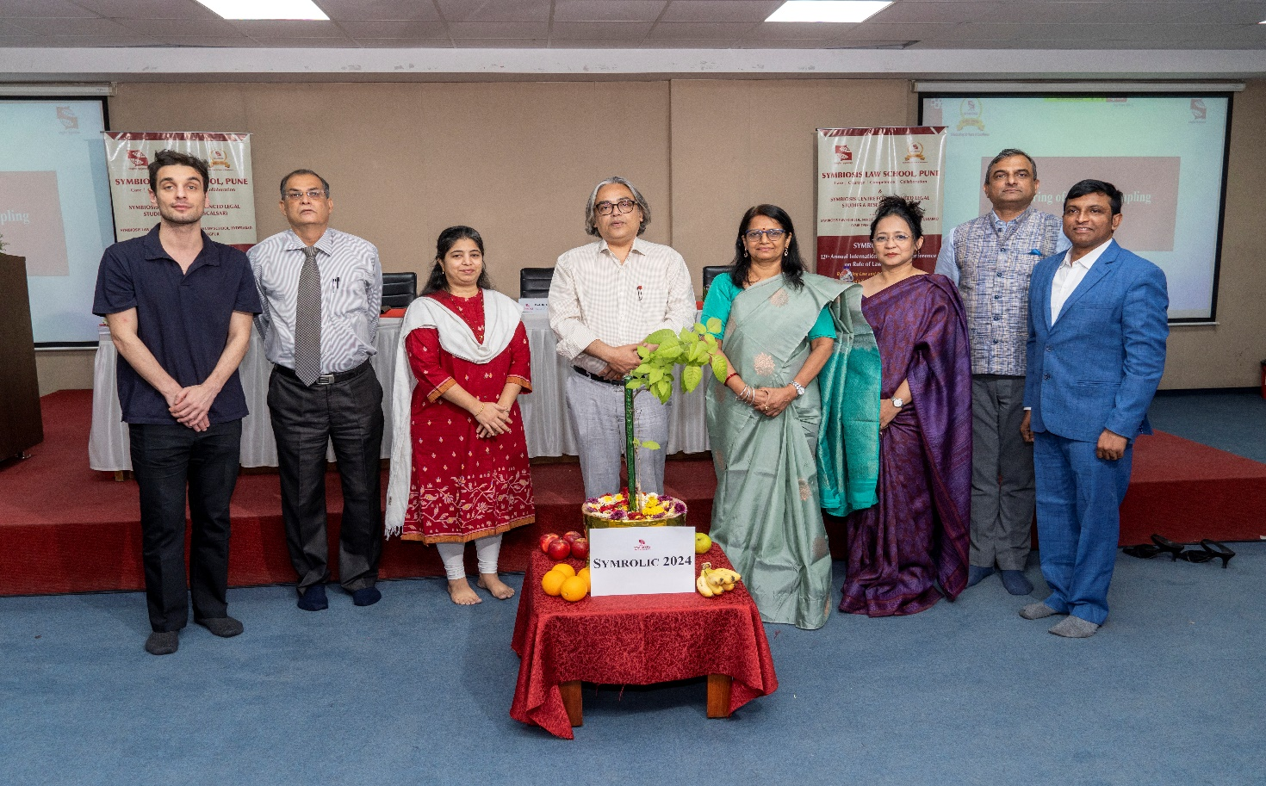

SYMROLIC 2024- Inauguration of 12th Annual International Research Conference-Rule of Law in Context: Rethinking Law and Policy with reference to Quality of Life as Global Economic Justice (SYMROLIC) on May 3 and May 4, 2024. Prof. (Dr.) Shashikala Gurpur, Fulbright Scholar, Director, Symbiosis Law School, Pune, Dean, Faculty of Law, SIU, Jean Monnet Chair (EUC LAMP co-funded by EU); Chief Guest, Prof. (Dr.) Indrajit Dube, Vice Chancellor, National Law University, Meghalaya; Prof. Dr. Sunder Korivi; Academic Head, HSNC University, Mumbai, Prof. Dr C J Rawandale, Director, Symbiosis Law School, Noida; Prof. Dr Rupal Rautdesai, Research Advisor and Visiting Professor, SLSP; Dr. Bindu Ronald, Professor & Co-head, SCALSAR, SLS Pune; Dr. Atmaram Shelke, Associate Professor, SLS Pune & Prof. Mr. Giorgi Parulava, Visiting Faculty, SPARC Project, Stockholm University, Sweden.

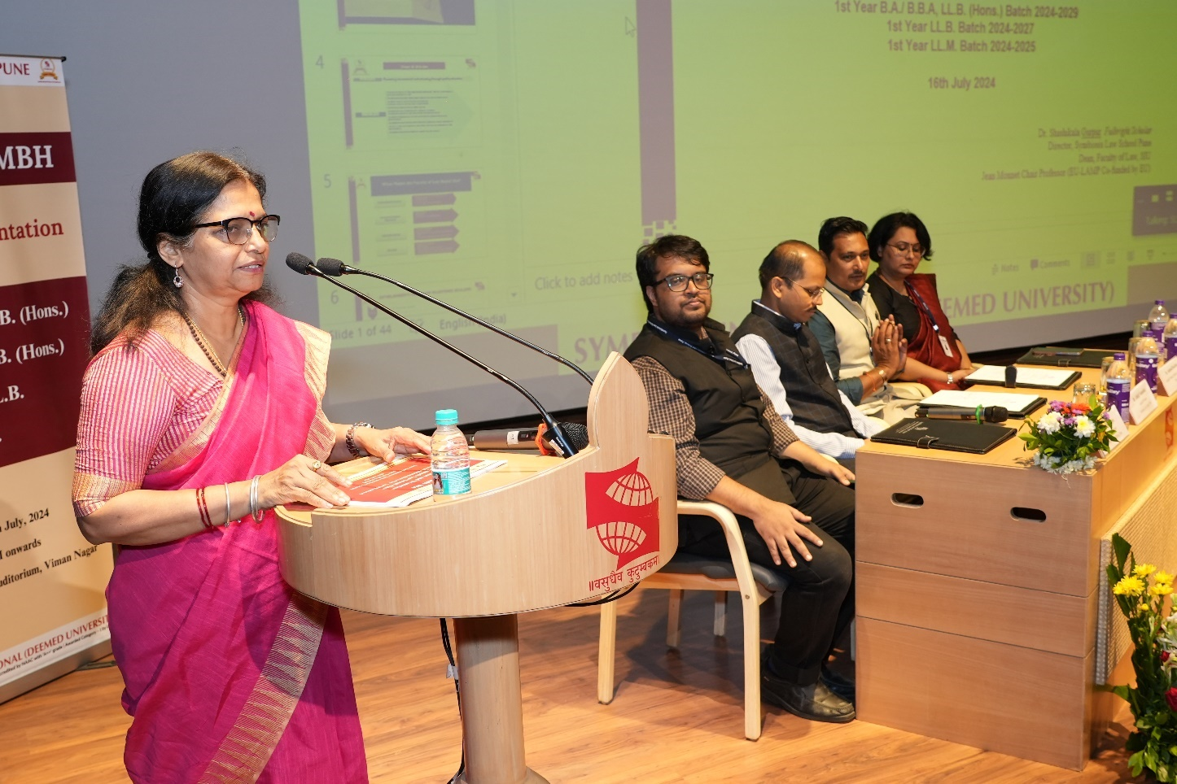
Deeksharambh (LLM Induction Program 2024): Prof. (Dr.) Shashikala Gurpur, Fulbright Scholar, Director, Symbiosis Law School, Pune, Dean, Faculty of Law, SIU, Jean Monnet Chair (EUC LAMP co-funded by EU). Prof. Ujal Kumar Mukherjee, Dr. Abhijit Vasmatkar, Prof. Ashutosh Panchbhai, Dr. Jayita Moulick, Assistant Professors, Symbiosis Law School, Pune.

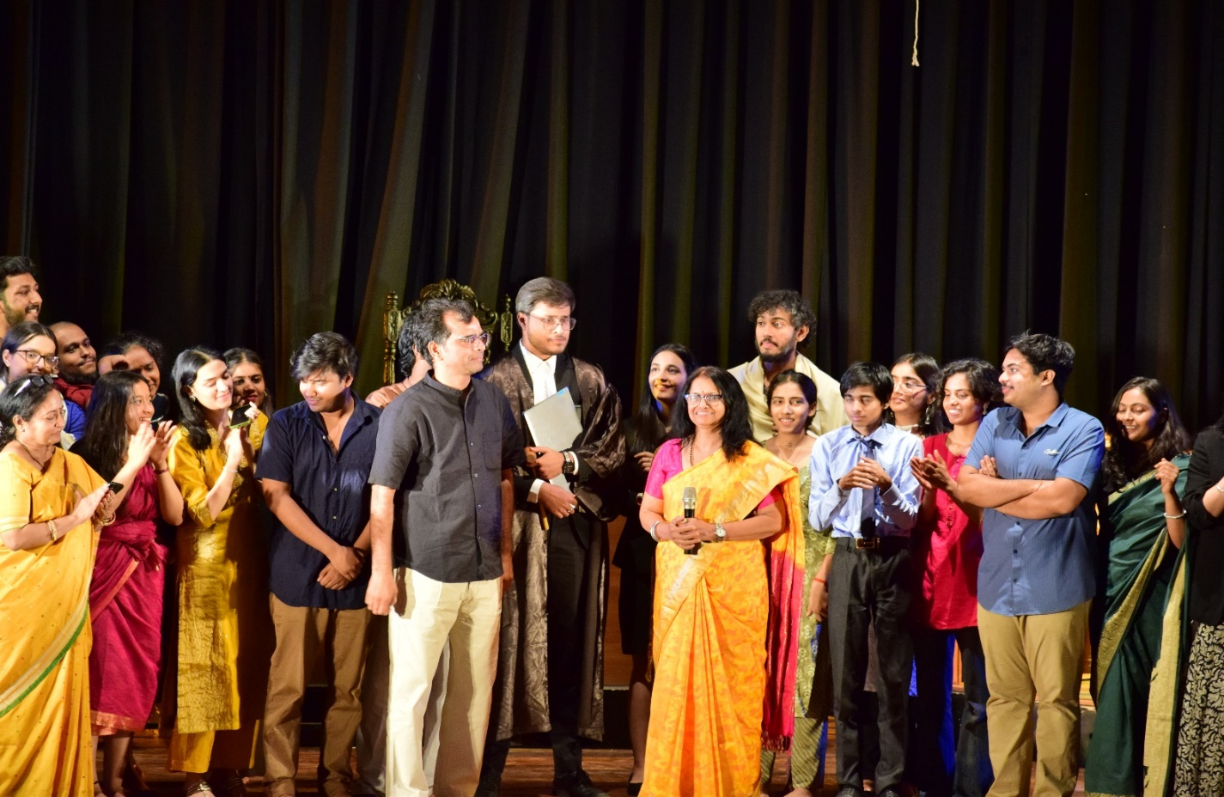

Symbhav 2024- Law Theatre Team: Prof. (Dr.) Shashikala Gurpur, Fulbright Scholar, Director, Symbiosis Law School, Pune, Dean, Faculty of Law, SIU, Jean Monnet Chair (EUC LAMP co-funded by EU); Mr. Sachin Malvi, Director, “Maaye Maati Chhodab Nahi” (I will not leave my Land); Ms Navya Om Alumni, SLSP &amp; Law Theatre Team, SLS Pune.

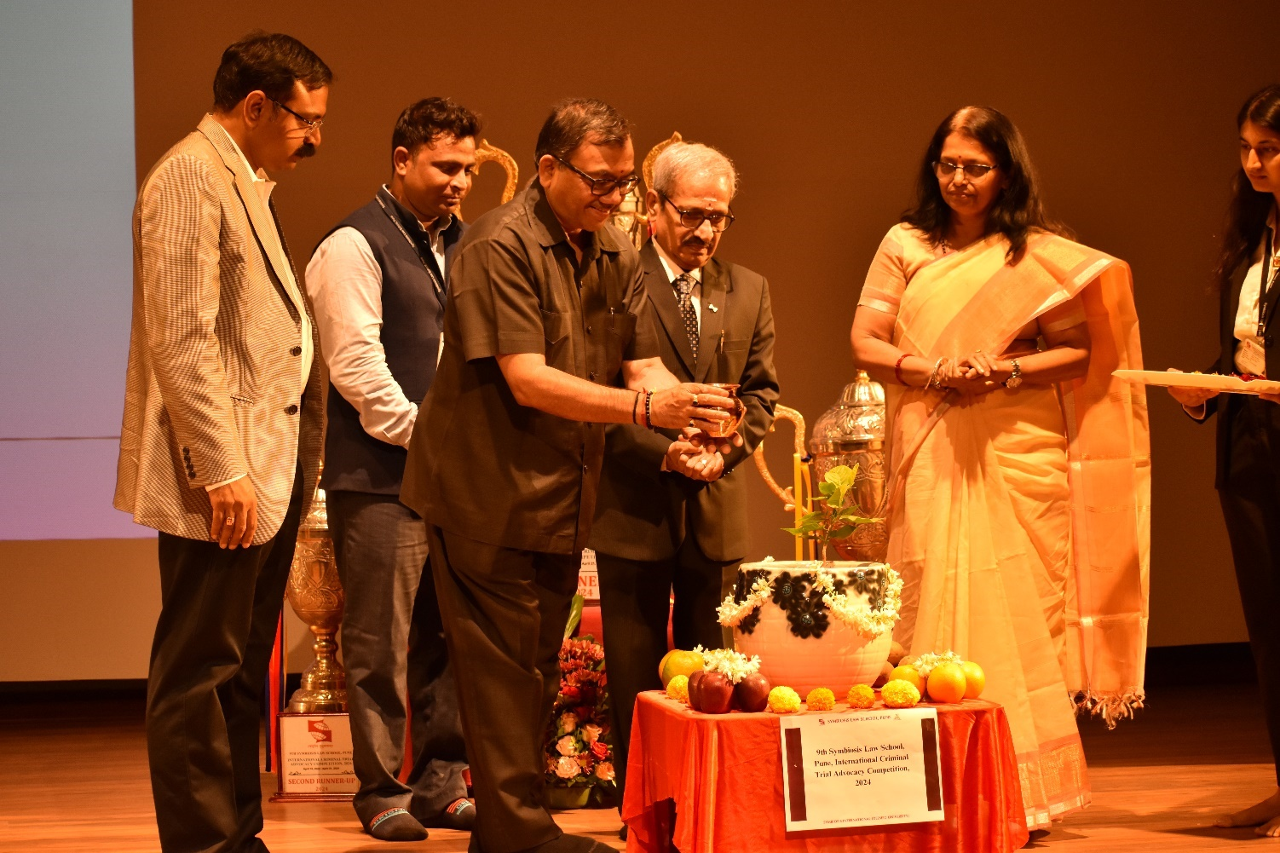
SICTA 2024: Inauguration ceremony of the Symbiosis International Criminal Trial Advocacy Competition, 2024. Prof. (Dr.) Shashikala Gurpur, Fulbright Scholar, Director, Symbiosis Law School, Pune, Dean, Faculty of Law, SIU, Jean Monnet Chair (EUC LAMP co-funded by EU). Dr. Rama Joga Rao, Additional Legal Advisor, Department of Legal Affairs, Ministry of Law & Justice, Government of India. Retd. Hon’ble Justice Mr. Mandhata Seetharama Murti, Chairperson, Andhra Pradesh State Human Rights Commission.

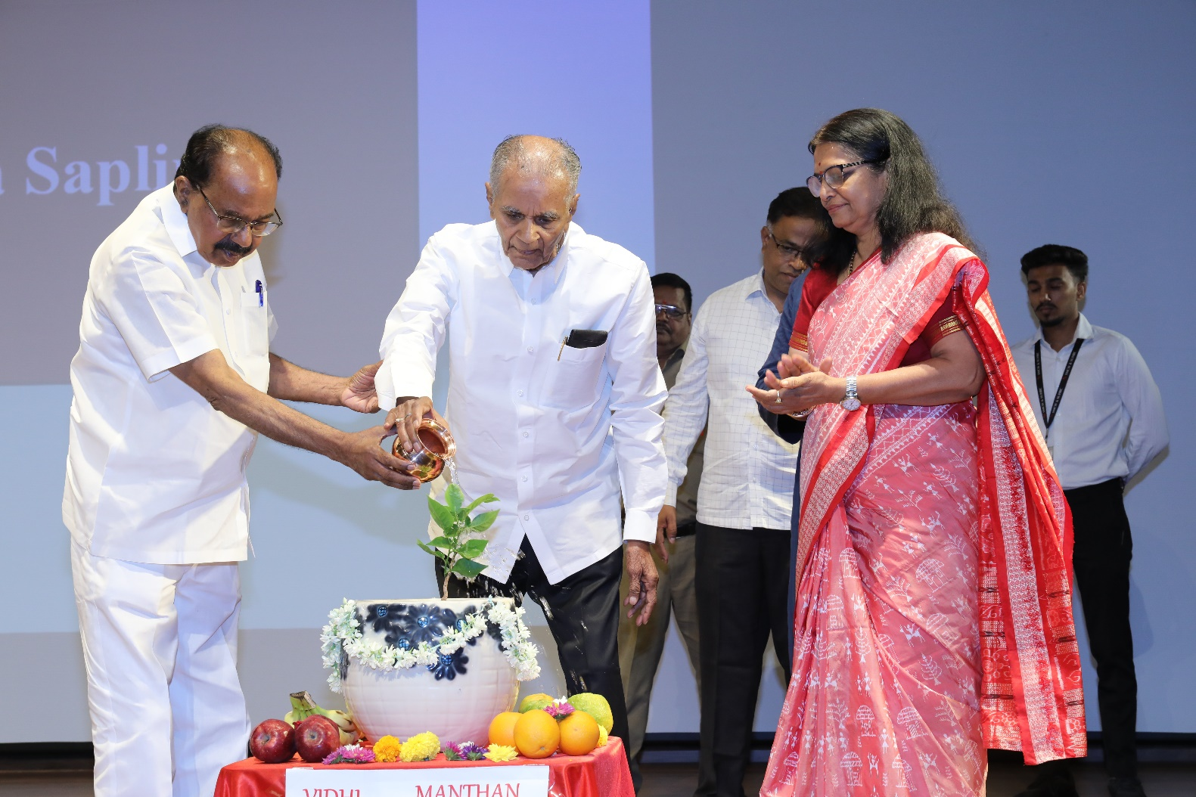

Law Day 2024- Law Day Oath, Justice Y.V. Chandrachud Memorial Public Lecture, 2024, and Symposium on Vidhi Manthan: Bharatiya Gyan Parampara in Law & Justice. Hon’ble Dr. M. Veerappa Moily, Former Chief Minister of Karnataka and Former Law Minister, Govt. of India, Prof. Dr. S B. Mujumdar, Hon’ble Chancellor, SIU, Founder and President, Symbiosis and Dr. Shashikala Gurpur, Fulbright Scholar, Director, Symbiosis Law School-Pune, Dean- Faculty of Law, SIU, Jean Monnet Chair Professor (EUC- LAMP co-founded by EU) and Mr Shantanu Lamdhade, State Coordinator, Pravah.

